
MERIDIAN JUNIOR COLLEGE
JC2 Preliminary Examination
Higher 2

___________________________________________________________________
H2 Mathematics 9740/01
Paper 1 11 September 2012

3 Hours
Additional Materials: Writing paper
List of Formulae (MF 15)
___________________________________________________________________

Write your name and civics group on all the work you hand in.
Write in dark blue or black pen on both sides of the paper.
You may use a soft pencil for any diagrams or graphs.
Do not use staples, paper clips, highlighters, glue or correction fluid.

Answer all the questions.
Give non-exact numerical answers correct to 3 significant figures, or 1 decimal place in the case of angles in degrees, unless a different level of accuracy is specified in the question.
You are expected to use a graphic calculator.
Unsupported answers from a graphic calculator are allowed unless a question specifically states otherwise.
Where unsupported answers from a graphic calculator are not allowed in a question, you are required to present the mathematical steps using mathematical notations and not calculator commands.
You are reminded of the need for clear presentation in your answers.

At the end of the examination, fasten all your work securely together.
The number of marks is given in brackets [ ] at the end of each question or part question.

READ THESE INSTRUCTIONS FIRST

___________________________________________________________________

This document consists of 7 printed pages and 1 blank page.
[Turn Over]

BLANK PAGE

1 By using an algebraic method, solve the inequality
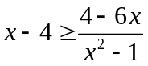. [4]

2 The graph of a cubic polynomial passes through the origin and only has one stationary point at 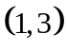. Find the cubic polynomial. [4]

3 (a) Given
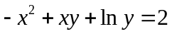,
find 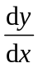. [2]
(b) (i) Find 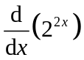. [1]
(ii) Hence find 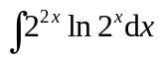. [3]

4 The complex number z satisfies 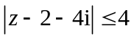 and 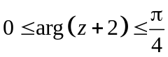.
(i) On an Argand diagram, sketch the region in which the point representing z can lie. [3]
(ii) Find the smallest value of 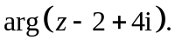 [1]
(iii) It is further given that the value of 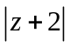 is minimum at point P. Find the complex number w representing P in the form 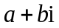, giving the exact values of a and b. [2]

5 Relative to the origin O, the points A and B have position vectors  and  respectively.
(i) The point M lies on AB extended such that AB:AM = 4:5. Find the position vector of M. [2]
(ii) Give a geometrical interpretation of 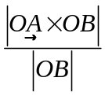. [1]
(iii) Find the shortest distance from the point 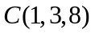 to the plane containing ,  and . [3]
[Turn Over]
6 Given that 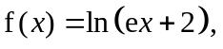 find 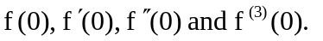 [2]
(i) Hence write down the first four non-zero terms in the Maclaurin series for 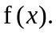 [1]
(ii) Using the series found in part (i), find the Maclaurin series for 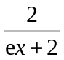, up to and including the term in x². [1]
(iii) By considering the standard series for 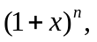 verify that the series obtained in part (ii) is correct. [2]

7 A sequence 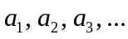 is such that 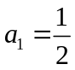 and
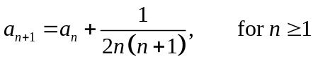
(i) By considering the values of 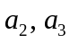 and 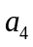, write down a conjecture for 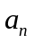 in the form of 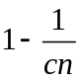, where c is a constant to be determined. [2]
(ii) Use the method of mathematical induction to prove the conjecture. [4]
(iii) Hence find 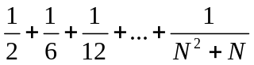 in terms of N. [4]

8 In the diagram below, triangle PQR is inscribed inside a circle of centre O and constant radius r. PR is a line that passes through the centre of the circle O. As point Q moves along the circle, the area of triangle PQR changes.
P
Q
R
O

(i) Using differentiation, find the length of the sides PQ and QR such that the maximum area of triangle PQR is obtained. Leave your answers in terms of r.
[7]
(ii) Given that QR increases at a rate of 0.2 units per second, find the rate of change of 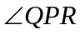 when 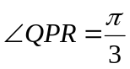and 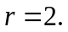 [3]

9 Runners A and B are undergoing two types of a training programme in preparation for a marathon.
Runner A: Runs 2.4 km on day 1, and on each successive day, the distance covered is increased by 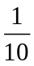of the previous day.
Runner B: Runs 4 km on day 1, and on each successive day, the distance covered is increased by 800 m.
(i) Find the total distance, to the nearest metre, runner A would have covered in the first 15 days. [2]
(ii) On day n, runner B meets her target of covering a distance of 42 km for the first time. Find n. [2]
(iii) In order for runner A to cover the same total distance as runner B by the end of day 3, the distance covered by runner A has to be increased by 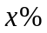 of the previous day on each successive day. Find x. [6]

[Turn Over]
10 (a) By means of the substitution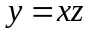, show that the differential equation
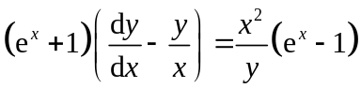
can be reduced to the form
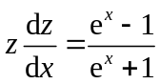.
Hence find the general solution for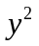in terms of x. [5]

(b) There was an island where initially there was no one living on it. The total capacity of the island is 9 000. The population increases at a rate which is inversely proportional to the remaining capacity of the island. At the same time, the rate at which the population decreases is 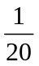of the population size. When the population reaches 4 000, it remains at this value. The population size (in thousands) is x at time t months, show that
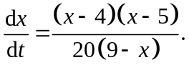
Find t in terms of x. Hence find the time when the population reaches 2 000.
[7]

11 (i) Find the fifth roots of 32, giving the roots in the form of 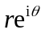, where 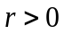 and
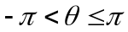. Show these roots on a sketch of an Argand diagram. [5]
(ii) The set of points in the Argand diagram representing the roots is denoted by S. State the number of points in S which are also in the locus of points representing the complex number v such that 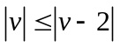. [1]
(iii) Two of the roots found in (i) are denoted by 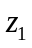and 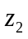, where
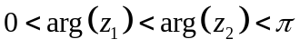. The complex number z is represented by the point of intersection of the loci of 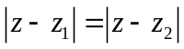and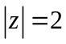. Find z, in the form of
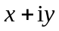, leaving the values of x and y in 2 decimal places. [2]
(iv) Using (i), show that all the roots of the equation in
can be expressed in the form of 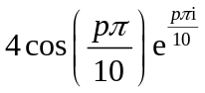, and state the values of p that give all the roots of the equation. [4]

[Turn Over]
12 (a) A curve C has equation
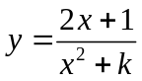 where .
- State a sequence of transformations which transform the graph of C to
the graph of 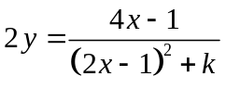. [3]
(ii) Given 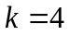, find the exact value of 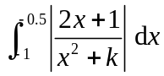. [6]

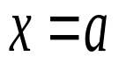
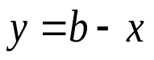
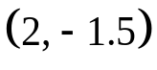
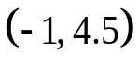
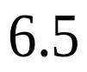

(b) The diagram below shows the graph of 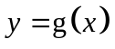.
y
x

Sketch the following graphs on separate diagrams,
(i) 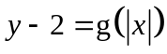, [3]
(ii) 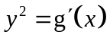, [2]
showing clearly in each case the intersection(s) with the axes, the coordinates of the turning point(s) and the equation(s) of the asymptotes.

